Logging using SLF4J
Exercise 1: Logging Error Messages and Warning Levels
LoggingExample.java:
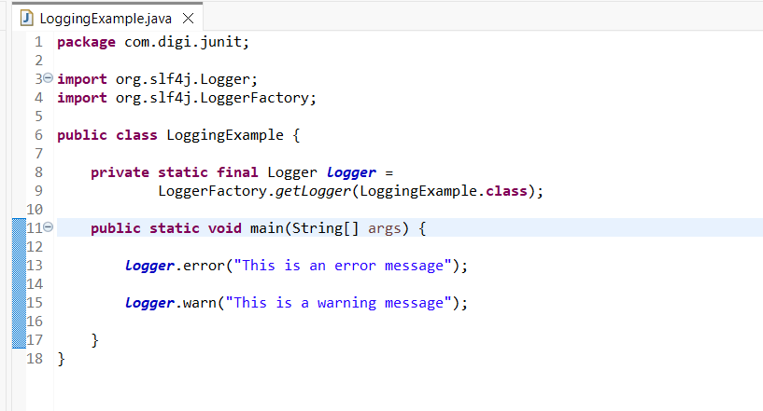
Output:
